Provincial Human Resource Management and Development Office Organizational Chart/Structure



PHRMDO, SG-26



# RECRUITMENT, SELECTION & PLACEMENT, AND ADMINISTRATIVE DIVISION

LEARNING AND DEVELOPMENT (L & D), REWARDS AND RECOGNITION (R & R), WELFARE& BENEFITS, & PERFORMANCE MANAGEMENT DIVISION

SUPERVISING ADMINISTRATIVE OFFICER, SG-22 (HRMO IV)

SUPERVISING ADMINISTRATIVE OFFICER, SG-22 (HRMO IV)





RECRUITMENT, SELECTION & PLACEMENT

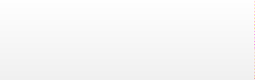

HRIS/ADMINISTRATIVE

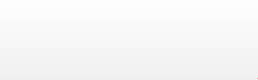

LEARNING AND DEVELOPMENT

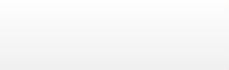REWARDS AND RECOGNITION, WELFARE & BENEFITS/ PERFORMANCE MANAGEMENT



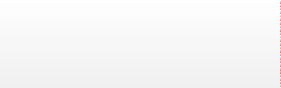ADMINISTRATIVE OFFICER V, SG-18 (HRMO III)

ADMINISTRATIVE OFFICER V, SG-18 (HRMO III)

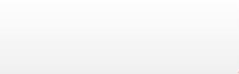

ADMINISTRATIVE OFFICER IV SG-15 (HRMO II)

ADMINISTRATIVE OFFICER IV, SG-15 (HRMO II)

ADMINISTRATIVE OFFICER IV, SG-15 (HRMO II)



ADMINISTRATIVE ASSSTANT II, SG-8 (HRM ASSISTANT)





ADMINISTRATIVE AIDE IV, SG-4

ADMINISTRATIVE AIDE IV, SG-4

CASUAL

ADMINISTRATIVE OFFICER II, SG-11 (HRMO-I)



ADMINISTRATIVE AIDE VI, SG-6

ADMINISTRATIVE AIDE IV, SG-4

ADMINISTRATIVE AIDE III, SG-3 (DRIVER I)





ADMINISTRATIVE AIDE IV, SG-4

ADMINISTRATIVE AIDE IV, SG-4

CASUAL

ADMINISTRATIVE OFFICER II, SG-11 (HRMO-I)

ADMINISTRATIVE ASSISTANT I, SG-7 (COMPUTER OPERATOR I)

ADMINISTRATIVE AIDE VI, SG-6

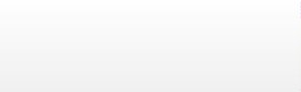

ADMINISTRATIVE AIDE IV, SG-4

ADMINISTRATIVE OFFICER II, SG-11 (HRMO-I)





ADMINISTRATIVE AIDE VI, SG-6

ADMINISTRATIVE AIDE VI, SG-6



ADMINISTRATIVE AIDE I, SG-1 (UTILITY WORKER I)

ADMINISTRATIVE AIDE IV, SG-4 CASUAL

LLEEGGEENNDD::

# Created position (New)



CCAASSUUAALLSS